What is a Laser?
A laser is a device that emits a beam of coherent light through an optical amplification process. There are many types of lasers including gas lasers, fiber lasers, solid state lasers, dye lasers, diode lasers and excimer lasers. All of these laser types share a basic set of components.
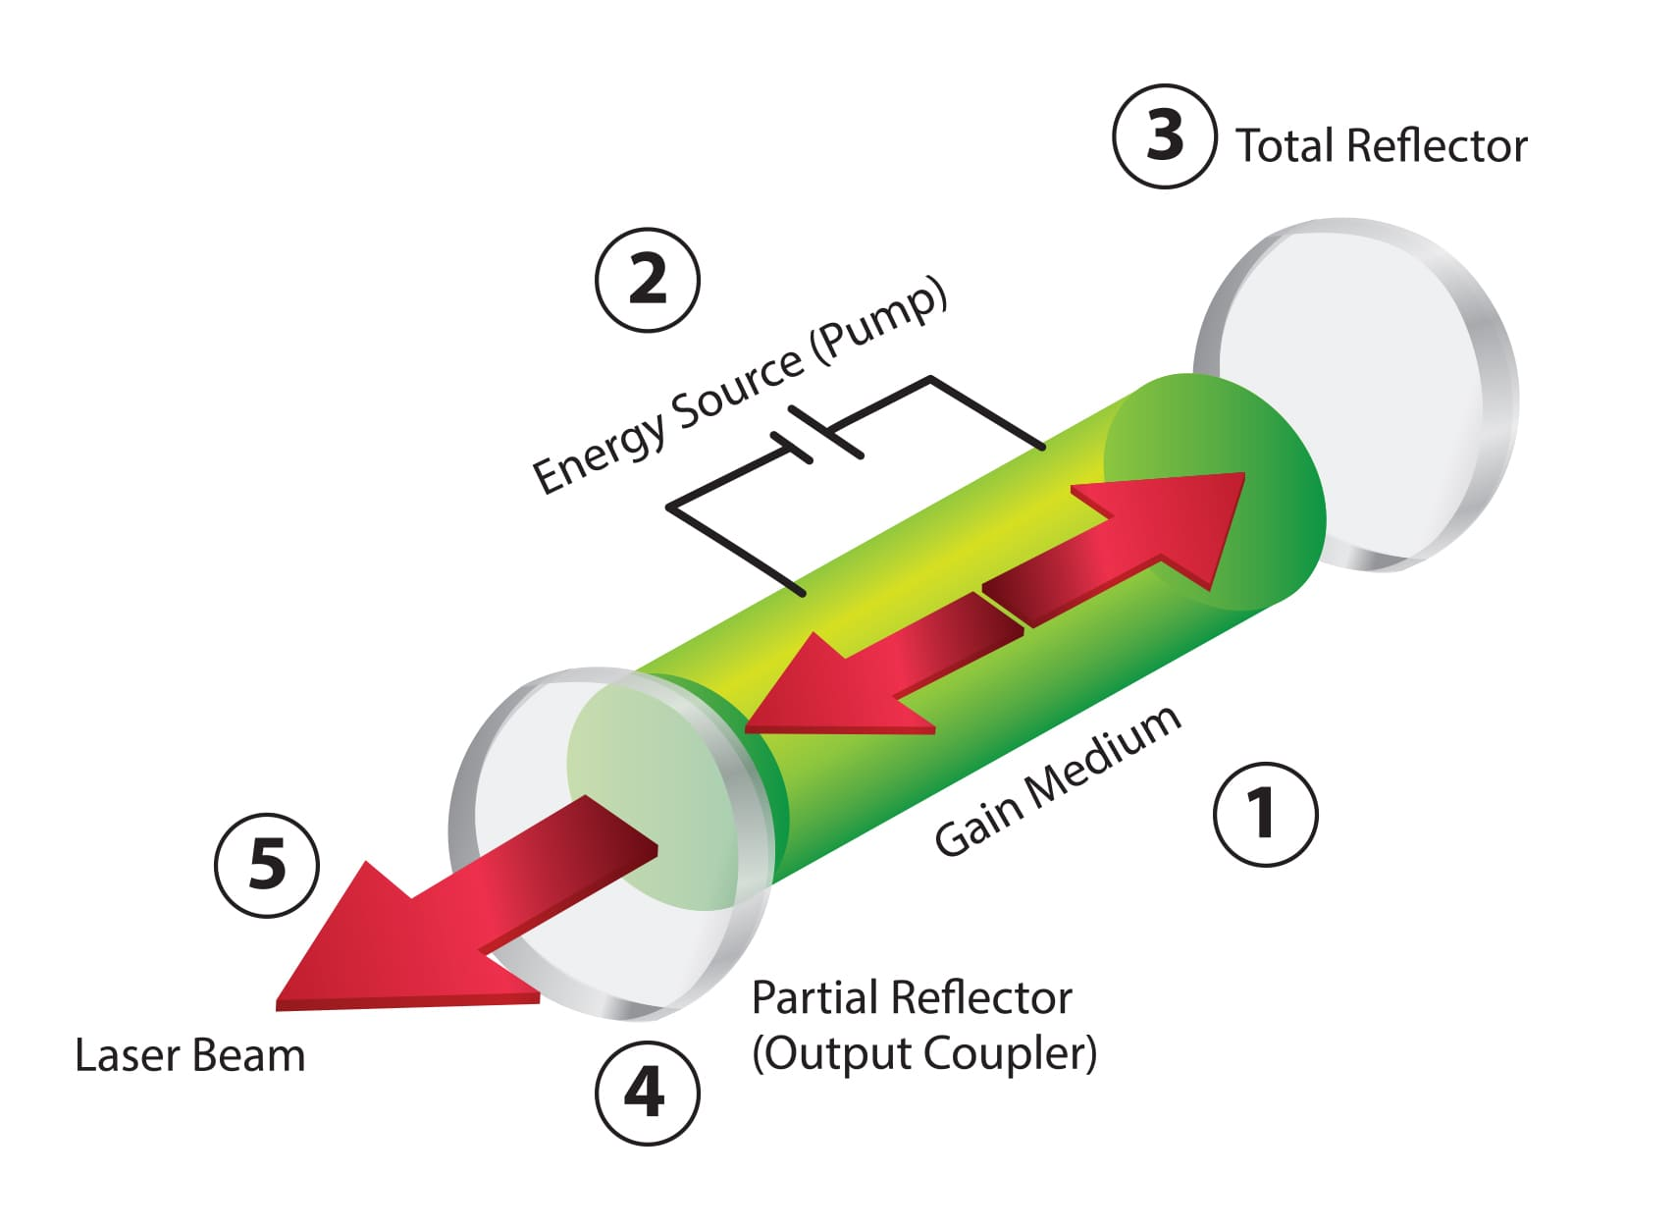
Laser Components
- Gain medium capable of sustaining stimulated emission
- Energy source to pump the gain medium
- Total reflector to reflect energy
- Partial reflector
- Laser beam output

How is Laser Technology Used?
Lasers are key components of many of the products that we use every day. Consumer products like Blu-Ray and DVD players rely on laser technology to read information from the disks. Bar code scanners rely on lasers for information processing. Lasers are also used in many surgical procedures such as LASIK eye surgery. In manufacturing, lasers are used for cutting, engraving, drilling and marking a broad range of materials.
There are many applications for laser technology including the following:

- Laser Range Finding
- Information Processing (DVDs and Blu-Ray)
- Bar Code Readers
- Laser Surgery
- Holographic Imaging
- Laser Spectroscopy
- Laser Material Processing
  - Cutting
  - Engraving
  - Drilling
  - Marking
  - Surface Modification

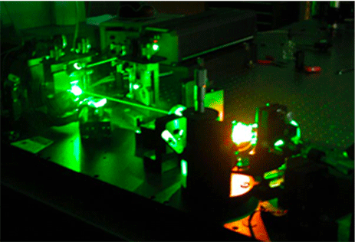

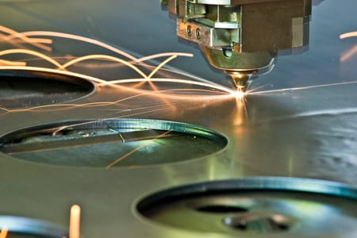

Laser Cutting
Laser cutting is the complete removal and separation of material from the top surface to the bottom surface along a designated path. Laser cutting can be performed on a single layer material or multi-layer material.
When cutting multi-layer material, the laser beam can be precisely controlled to cut through the top layer without cutting through the other layers of the material. (See Figure 1 below.)
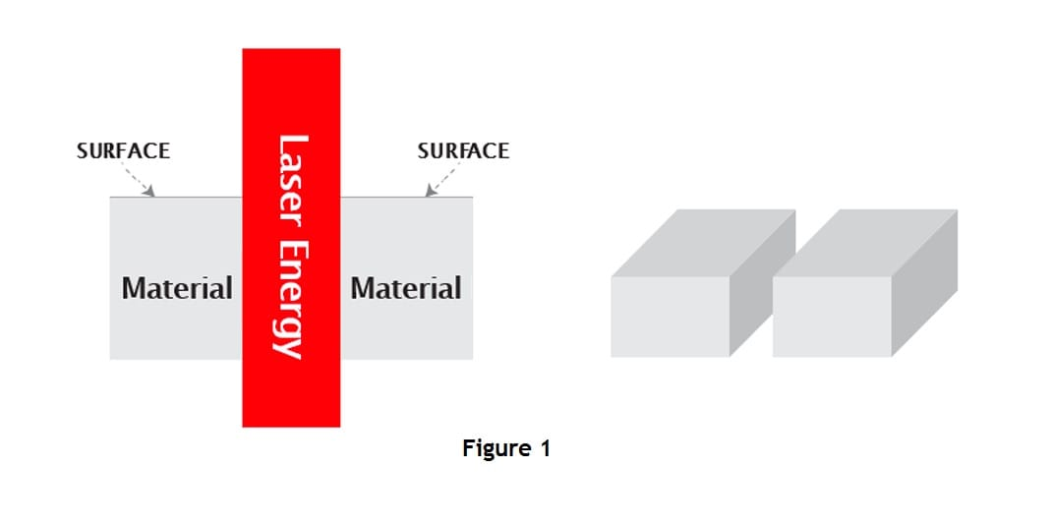

Material thickness and density are important factors to consider when laser cutting. Cutting through thin material requires less laser energy than cutting the same material in a thicker form. Lower density material typically requires less laser energy. However, increasing laser power level generally improves laser cutting speed.

In general, CO₂ lasers with 10.6 micron wavelength are primarily used for cutting non-metal materials. CO₂ and fiber lasers are both used for cutting metals. However, as a rule, cutting metals requires substantially higher power levels than non-metal materials.

Learn more about why laser technology is an ideal tool for meeting tight tolerance specifications when used as a laser cutter and how laser technology enables distinctive design characteristics when used as a laser engraver or laser marker.
- Laser Annealing
The energy of the laser beam heats the material directly in its path causing it to undergo a phase change (for example, from amorphous to polycrystalline).
Laser Cutting
Complete removal and separation of a material from the top surface to the bottom surface along a designated path.

- Laser Drilling
Removal of material by applying focused laser energy to a material without moving the laser beam during the process.

- Laser Engraving/Etching
Removal of material from the top surface down to a specified depth.

- Laser Machining
Controlled material removal through a combination of laser cutting, laser engraving and laser drilling to create a certain shape, size or appearance.

- Laser Marking
Modification of the surface of a material to create human and/or machine readable alphanumeric characters, 1D/2D barcodes, logos, insignia, etc. mainly for the purpose of identification.

- Laser Perforating
Process of creating a pattern of holes through a material.

- Laser Photo Engraving
Laser engraving or laser marking of a photo image onto the surface of the material.

- Laser Scoring
Partial removal of material along a designated path for the purpose of folding or breaking the material along that path.

